9/19/25 10:05 home to hallway - amcl & fb_pose(!isMoving)

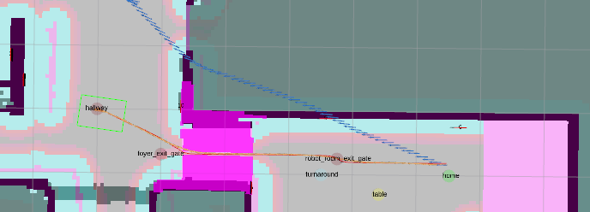

9/19/25 10:15am dorrway to coat “failed to make progree” but only because picoted back-and-forth while at goal

